Sample Facebook Posts for Give Kids a Smile 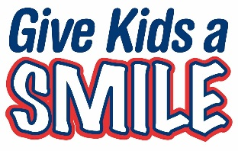

PRE-EVENT
Kicking off National Children’s Dental Health Month in February, (Name of Clinic) is participating in Give Kids a Smile, a charitable dental event for kids who cannot access dental care. We will be providing free dental care to kids on (date). Call (phone number) for more information and to schedule an appointment.
We love to see healthy smiles! That’s why our office is volunteering for Give Kids a Smile on (date). We are eager to provide dental care to kids who face barriers to accessing care. Call our office (phone number) to set up an appointment. No questions asked.
Tooth decay is the number one disease in children. To help kids in need, (Clinic name) is offering appointments for free dental care through the Minnesota Dental Foundation’s Give Kids a Smile program. Call our clinic at (phone number) to schedule an appointment today.
POST EVENT
On (date), (clinic name) hosted a Give Kid a Smile event and put smiles back on the faces of many children in our community. It was a very rewarding experience, and we are delighted to have helped out so many kids in need of care.

